Automated Labeling and Prediction of Future Growth in Emerging Consumer Packaged Goods
Drew Nunnally1, Devin Streeter1, Kristin Henderson1, Bivin Sadler1
1 Master of Science in Data Science, Southern Methodist University,
Dallas, TX 75275 USA
{dnunnally, dstreeter, hendersonk, bsadler}@smu.edu
Abstract. Spirits brokers and distributors need a reproducible way to identify brands that may achieve sales growth in the future. This study develops a proposed screening approach that combines automated outcome labeling with a prediction model. Observations are aggregated to brand-extension sales volume totals in consecutive 52-week periods. Growth from the first to the second period supplies the initial predictor, while growth from the second to the third period defines the binary outcome. A positive label is assigned when subsequent growth exceeds 40%, a threshold to be examined through sensitivity analysis and stakeholder discussion. The proposed output is a probability of exceeding the sales-growth threshold. [Results and conclusion]
1 Introduction
Evaluating an emerging consumer-packaged-goods brand requires a decision before its long-term performance is known. Sales history may show growth without establishing whether that growth will persist and provide little evidence of consistent future performance. In a study of 36,994 new line extensions, Victory et al. found that 72% had a market share below their category average in the quarter after launch, compared to approximately 66% three years later [1]. These results concern the categories and markets examined in that study rather than specifically spirits. However, they illustrate why the definition and timing of product success matters when translating observed sales into a decision.
The setting for this project is an industry partner’s interest in identifying spirits brands that merit further business consideration. The analytical task is to screen brand extensions for future case-sales growth using information available at a defined decision date. A brand extension is the unit formed by aggregating the relevant product-level observations under the extension identifier in the supplied data. It may represent only part of a brand family. An extension’s predicted sales growth cannot by itself establish the value of a business, the attractiveness of an acquisition, or the return on that investment.
Henderson and Sadler developed a framework for evaluating emerging consumer-packaged-goods brands using demand-based features and a multi-criteria decision analysis opportunity score [2]. Their study trained and evaluated models with a hand-labeled set of 112 brands in one subcategory and examined a separate stakeholder-provided set of 18 brand families. On the hand-labeled task, binary logistic regression achieved approximately 84% balanced accuracy while the opportunity score achieved up to 85%. The ordinal model’s 93% adjacent accuracy counted predictions within one ordered tier of the assigned label. These results support further investigation of simple demand features, while the lower external validation also indicates that results depend on the evaluation population and outcome definition [2].
This study builds on that use of demand information by focusing on a forward-looking outcome. Rather than assigning the previous study’s discontinued, decline, stable, and growing tiers, the proposed workflow labels whether an extension exceeds a chosen sales-growth threshold during a subsequent period. The task can be applied repeatedly to eligible historical windows without manually interpreting sales trajectory. Its scientific question is whether the earlier growth pattern contains useful information about this later outcome. The reliability of the calculation and the usefulness of the business definition remains a separate question.
Retail prediction research makes clear that the unit of analysis and the decision being supported shape the modeling problem. Fildes et al. distinguish forecasts across product and organizational levels and review the effects on promotion, limited histories, and heterogeneous demand patterns [3]. In beverage alcohol distribution, Arora et al. found substantial improvements over naïve forecasts for selected products but also found that successful models required product-specific tuning [4]. Jiang et al. likewise reported forecast improvements for several product-customer combinations, with performance varying by series and method [5]. Ford et al. developed an automated framework that selected among models for individual product-consumer combinations [6]. These studies motivate benchmarks and careful evaluation; they do not establish in advance that classification will outperform forecasting.
Classification offers a useful way to express the narrower screening decision in this project. A probability of exceeding a defined growth threshold may help prioritize further examination when reviewing every extension in detail is not practical. Hirche et al. provide a related example of classifying retail performance; their models distinguish underperforming, in-line, and overperforming SKUs relative to the distribution-market-share relationship [7]. Their outcome, data structure and time frame differ from those proposed here. The connection is the use of an explicit performance definition to turn a broad managerial question into a measurable analytical task.
For the initial proof of concept, the decision date falls at the end of the second of three consecutive 52-week periods. The model receives growth from the first period to the second and predicts whether growth from the second period to the third exceeds the specified threshold. This makes the information boundary visible. Future growth constructs the retrospective label but is unavailable to the model at the decision date.
This design also narrows what the study can claim. Two input periods are required, so the baseline does not evaluate a brand at launch or solve predictions without sales history. An extension that stops selling in the outcome year has a growth of negative 100% and is labeled 0, so no separate survival rule is needed. Very small starting volumes, however, can produce extreme percentage changes, so a minimum-volume rule is required. The eligible population, the treatment of extensions with no sales in a period, and the share of positive labels are examined in Section 3 before any predictive performance is reported.
The research question is whether growth observed before a decision date can improve prediction of a subsequent sales growth threshold relative to simple screening baselines. The proposed contribution is a reproducible target definition and an evaluation that preserves the timing of available information. An operational dashboard may later expose the growth threshold and prediction cutoff for stakeholder exploration. Its usefulness will depend on validated predictions and an agreed interpretation of the outcome rather than the interface alone.
2 Literature Review
2.1 Defining Performance for Brand Screening
Product success can refer to survival, market capture, volume growth, relative performance, or a financial outcome. These measures sometimes overlap but are not interchangeable. Victory et al. examine multiple measures of new-line-extension performance and show why a single average can conceal a skewed distribution [1]. Their mean market share of 0.3% should not be interpreted as a representation of every new product. The same study’s failure statistics also require attention to seasonal products. For this project, that evidence supports specifying the outcome and observation period before choosing the model.
Henderson and Sadler use trajectory-based tiers to evaluate brand opportunity and compare an opportunity score with binary and ordinal models [2]. Hirche et al. instead define performance relative to a distribution-market-share curve and report approximately 83% correct classification across three SKU-performance classes in their study [7]. Both approaches translate business performance into a structured target, but neither defines success as exceeding the future growth threshold. Their reported accuracy provides context rather than directly comparable performance targets.
Distribution and category conditions add complications to interpretation of growth. Michis proposes a semiparametric brand-level sales-response model in which the relationship between distribution and sales is nonlinear and may be convex, concave, or S-shaped [8]. Bronnenberg and Sismeiro show how retail structure and geographic relationships can inform predictions for markets with limited data [9]. Dunn et al. analyze revenue changes across consumer-packaged-goods categories and identify category penetration and price per volume as major growth components [10]. Together, these studies suggest that growth can reflect changes in the surrounding market as well as extension-specific demand. They justify examining category differences and acknowledging omitted context even when the first model intentionally uses one predictor.
2.2 Forecasting Evidence and Simple Baselines
The retail forecasting review by Fildes et al. describes problems that vary with aggregation level, available explanatory variables, and the decision horizon [3]. These are relevant because this project aggregates weekly product observations to extension-level annual case totals. Annual aggregation provides comparable seasonal windows and reduces the number of observations needed to define the target but also removes within-year timing information. A model based on annual growth cannot be interpreted as predicting weekly inventory demand or the timing of a sales peak.
The alcohol-distribution studies offer examples of heterogeneous results. Arora et al. developed ensemble approaches and report forecast-error reductions for the products studied [4]. Jiang et al. compared time-series and deep-learning models with naïve models for vodka product-customer combinations and find that the preferred model is not uniform across combinations [5]. Ford et al. respond to this variation with automated model selection and explicit checks of the time series being modeled [6]. The common implication for the present study is to demonstrate added value against a transparent baseline, rather than assuming that a fitted model is useful.
Ulrich et al. formulate retail forecast-model selection as a classification problem, assigning classes according to which forecasting method performs best under the chosen objective [11]. Their evaluation considers economic profitability through shortage and inventory costs. This is a different decision from selecting a brand for investment, but it shows why an evaluation criterion should follow the intended use. In the present study, a false positive means predicting that an extension will exceed the sales-growth threshold when it does not. It does not directly quantify money lost on an investment. Financial consequences require specified costs, margins, and decision rules.
2.3 Automated Labels and Learning across Products
Automated labels make a supervised task reproducible only when their meaning and limitations are explicit. Lam et al. study programmatic labeling through functions that produce weak labels, with attention to coverage, reliability and downstream classification quality [12]. Their Expona framework generates and filters many heuristic labeling functions and is evaluated on classification datasets from several domains. This study’s label is simpler: it calculates an observed future-sales ratio and applies a fixed threshold. The connection is the need to evaluate label coverage and validity separately from performance of a model trained on those labels.
The threshold label is a reproducible statement about whether a specified growth occurred. Its interpretation as an attractive investment remains a business hypothesis. A model can predict that rule well, even when the rule does not represent the stakeholder’s preferred decision. However, low predictive performance may indicate that earlier growth is not sufficient, not that the rule was calculated incorrectly. This is important when comparing a new binary outcome with Henderson and Sadler’s manually assigned tiers [2].
Research on learning across products offers potential extensions if separate category models have limited data. Zhu et al. use cross-series training and supply chain information in pharmaceutical demand forecasting [13]. Lei et al. develop a transfer-learning approach that combines category-level and product-level information for retail demand prediction [14]. These studies show ways to share information, but their forecasting methods and industry settings differ from a one-predictor growth classifier. The initial pooled logistic model should therefore be evaluated on its own terms. More complex pooling or category-specific models are later comparisons, depending on sample size and evidence of heterogeneous relationships.
2.4 External Information and Scope of the First Experiment
External information may capture factors absent from historical sales. Kumar et al. combine historical supermarket demand with news and Google Trends information in a multimodal forecasting model [15]. Pozner et al. examine how audience growth changes craft-beer evaluations and penalties associated with authenticity violations [16]. These studies are focused on demand forecasts and consumer rating, and do not validate acquisition recommendations. They identify possible influences outside of the current dataset while also showing why adding information would require a separate data collection and evaluation effort.
Literature supports a focused first experiment with bounded claims. The proposed hypothesis is that prior-year sales growth contains enough information to improve future-growth screening over majority-class baselines. The hypothesis is evaluated using a common label, sample and held-out period. Category differences, label prevalence, and the effect of sample restrictions will be examined alongside predictive performance. Claims that the resulting output probabilities identify attractive investments will require further validation and financial information.
3 Methods
3.1 Data
The data are NielsenIQ (NIQ) retail scanner records supplied by the industry partner under a non-disclosure agreement. The raw feed contains 77,063,935 rows across all alcohol megacategories and several NIQ markets. Each row is one product (UPC) in one market in one week and carries 29 fields: product identifiers (UPC, item description, brand owner, manufacturer, brand family, brand extension, category, subcategory, and price tier), sales measures (dollars, units, and cases, each with NIQ’s baseline and incremental estimates), price measures, a distribution measure (percent ACV), and dollar share of the megacategory.
Two filters define the study population. The first keeps the TOTAL SPIRITS megacategory. The second keeps the Total US Liquor Open State market, the same market used to prepare the data for the earlier study. The result is 7,334,190 rows covering 260 weekly periods, from the week ending January 23, 2021 to the week ending January 10, 2026. NIQ’s text period label is converted to a week-ending date and a week number from 1 to 260, and weeks are grouped into five 52-week years beginning in late January, labeled 2021 through 2025. Annual case totals are then computed for each brand extension, the unit of analysis. The filtered data contain 46,008 UPCs, 22,495 brand extensions, and 11 categories. As a check on the preparation, the row count, number of weeks, number of UPCs and extensions, total cases, total dollars, and the case total in every week were compared with the file prepared for the earlier study and matched exactly.
Cases are the sales measure, as in the earlier study [2], because dollar sales also move with price and unit counts ignore bottle size. Percent ACV measures how widely a product is stocked, so it is kept as a possible predictor rather than used in the label. The data are used as delivered; the study has no control over store participation, product coverage, or the reporting process.
3.2 Label Construction
Let C1, C2, and C3 be an extension’s case totals in three consecutive 52-week years. The predictor is growth from Year 1 to Year 2, g12 = C2 / C1 - 1. The outcome is growth from Year 2 to Year 3, g23 = C3 / C2 - 1. Given a growth threshold τ, the label is y = 1 when g23 > τ and y = 0 otherwise. Five years of data give three windows: 2021 to 2023, 2022 to 2024, and 2023 to 2025. The decision date is the end of Year 2 in each window, so the model observes g12 and never observes g23.
An extension is eligible in a window when C1 and C2 are each at least m cases. Without a minimum, an extension moving from one case to ten would show 900% growth. An extension with no sales in Year 3 has g23 = -1 and is labeled 0, which handles discontinuation without a separate survival rule. An extension can appear in more than one window, so the three windows are not independent samples. Both τ and m are settings rather than fixed parts of the method. This draft uses τ = 0.40 (growth of more than 40%) and m = 52 (roughly one case per week) as starting values pending discussion with the industry partner. The labeling code was verified on a small hand-constructed dataset with known answers and on the four illustrative products used in advisor discussions.
Table 1. Eligible brand extensions and positive labels by window (τ = 0.40, m = 52).
Window | Eligible extensions | Labeled 1 | Share labeled 1
2021 to 2023 | 8,490 | 693 | 8.2%
2022 to 2024 | 8,634 | 632 | 7.3%
2023 to 2025 | 8,799 | 582 | 6.6%

At these settings, about 7% of eligible extension-windows receive a positive label (Table 1), roughly 1,900 positive cases in total. The imbalance is expected, since growth of more than 40% in one year is uncommon for an established product. It also means that accuracy is not an informative metric: predicting 0 for every extension would be about 93% accurate. Evaluation therefore focuses on ranking quality, described in Section 3.4.
3.3 Preliminary Exploratory Analysis
Figure 1 shows weekly case volume for all spirits and for each category. Total volume is roughly flat across the five years with strong holiday peaks. Categories move differently: prepared cocktails show strong summer seasonality with rising peaks, tequila rises steadily, and whiskey and vodka drift downward. Growth therefore partly reflects the category an extension belongs to, which supports adding category as a predictor in later models.
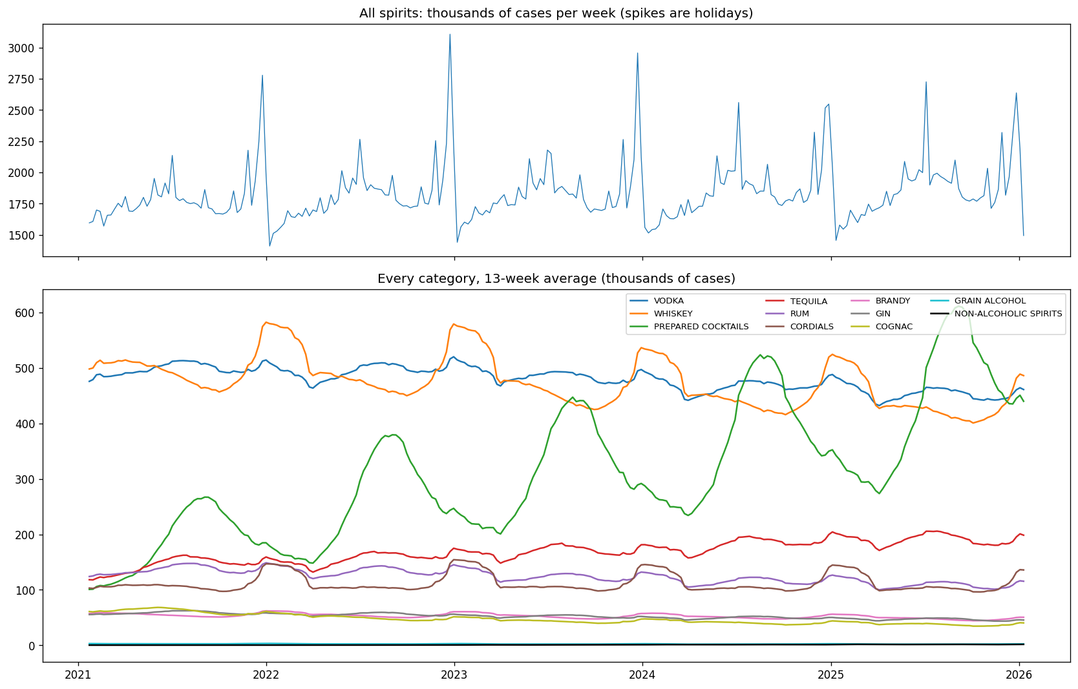
Fig. 1. Weekly cases for all spirits (top) and for each category as a 13-week moving average (bottom), January 2021 to January 2026.
References
1. Victory, K., Tanusondjaja, A., Dawes, J., Romaniuk, J., & Nenycz-Thiel, M. (n.d.). How do new products perform? An investigation [Manuscript]. SSRN. https://ssrn.com/abstract=4137036
2. Henderson, K., & Sadler, B. (n.d.). A decision framework for identifying high-potential emerging consumer-packaged goods brands [Manuscript]. Southern Methodist University.
3. Fildes, R., Ma, S., & Kolassa, S. (2022). Retail forecasting: Research and practice. International Journal of Forecasting, 38, 1283-1318. https://doi.org/10.1016/j.ijforecast.2019.06.004
4. Arora, T., Chandna, R., Conant, S., Sadler, B., & Slater, R. (2020). Demand forecasting in wholesale alcohol distribution: An ensemble approach. SMU Data Science Review, 3(1), Article 7. https://scholar.smu.edu/datasciencereview/vol3/iss1/7
5. Jiang, L., Rollins, K. M., Ludlow, M., & Sadler, B. (2020). Demand forecasting for alcoholic beverage distribution. SMU Data Science Review, 3(1), Article 5. https://scholar.smu.edu/datasciencereview/vol3/iss1/5
6. Ford, J., Nava, C., Tan, J., & Sadler, B. (2020). Automated machine learning framework for demand forecasting in wholesale beverage alcohol distribution. SMU Data Science Review, 3(3), Article 7. https://scholar.smu.edu/datasciencereview/vol3/iss3/7
7. Hirche, M., Farris, P. W., Greenacre, L., Quan, Y., & Wei, S. (2021). Predicting under- and overperforming SKUs within the distribution-market share relationship. Journal of Retailing, 97(4), 697-714. https://doi.org/10.1016/j.jretai.2021.04.002
8. Michis, A. A. (2023). Retail distribution evaluation in brand-level sales response models. Journal of Marketing Analytics, 11, 366-378. https://doi.org/10.1057/s41270-022-00165-8
9. Bronnenberg, B. J., & Sismeiro, C. (2002). Using multimarket data to predict brand performance in markets for which no or poor data exist. Journal of Marketing Research, 39(1), 1-17.
10. Dunn, S., Nenycz-Thiel, M., Graham, C., Dawes, J., Danenberg, N., Tanusondjaja, A., Trinh, G., & McColl, B. (2025). How categories grow: The behavioural drivers of revenue growth. Journal of Business Research, 195, Article 115385. https://doi.org/10.1016/j.jbusres.2025.115385
11. Ulrich, M., Jahnke, H., Langrock, R., Pesch, R., & Senge, R. (2022). Classification-based model selection in retail demand forecasting. International Journal of Forecasting, 38, 209-223. https://doi.org/10.1016/j.ijforecast.2021.05.010
12. Lam, P., Nguyen, H.-L., Nguyen, T.-T., Nguyen, S., & Vo, H. D. (2026). Structured exploration and exploitation of label functions for automated data annotation. Knowledge-Based Systems, 342, Article 115843. https://doi.org/10.1016/j.knosys.2026.115843
13. Zhu, X., Ninh, A., Zhao, H., & Liu, Z. (2021). Demand forecasting with supply-chain information and machine learning: Evidence in the pharmaceutical industry. Production and Operations Management, 30(9), 3231-3252. https://doi.org/10.1111/poms.13426
14. Lei, D., Qi, Y., Liu, S., Geng, D., Zhang, J., Hu, H., & Shen, Z.-J. M. (2025). Pooling and boosting for demand prediction in retail: A transfer learning approach. Manufacturing & Service Operations Management, 27(6), 1779-1794. https://doi.org/10.1287/msom.2022.0453
15. Kumar, N., Dheenadayalan, K., Reddy, S., & Kulkarni, S. (2022). Multimodal neural network for demand forecasting. arXiv. https://arxiv.org/abs/2210.11502
16. Pozner, J.-E., DeSoucey, M., Verhaal, J. C., & Sikavica, K. (2022). Watered down: Market growth, authenticity, and evaluation in craft beer. Organization Studies, 43(3), 321-345. https://doi.org/10.1177/0170840621993236

